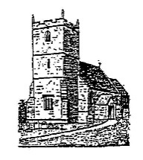
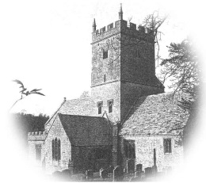
St Michael and All Angels’ Church with St Eadburgha’s Church, Broadway and St John the Baptist Church, Wickhamford
Revd M Ward
The Vicarage, Church Street, Broadway, Worcs, WR12 7AE
Tel: 01386 852352 e-mail: broadwaycofe@gmail.com
Charity Registration Number - 1129380

Church life after COVID-19
An invitation to reflect and respond

Name (optional):
Usual service attended and where:

COVID-19 has changed our experience of church life significantly. As we move slowly towards the possibility of returning to our church buildings for private prayer, services (albeit different from what we’re used to) and greater social interaction, I thought it would be useful to reflect on what we have gained and lost during these weeks since we left our physical churches in March.

Do we want church life just to return to what it was like before, or are there things that have started during the pandemic that we wish to continue, or are there things that we haven’t really missed?

Your answers to these questions will help us discern how to move forwards into the future.

This survey is divided into two sections.

The first section asks very open questions about our Church Life and Community Witness. What have we lost and gained?

The second section is very specific about what you have valued that is new about our worship and communications with one another.

Please complete as much of the form as you wish and return it me, preferably by email. Let me know if your copy needs to be collected from you at home. This survey will help me and our PCC’s as we complete our risk assessments.

Thank you

Shellie

Section 1: Church Life and Community Witness

- What have we lost in since lockdown as a church that must remain lost?

- What has been lost that we must regain in the weeks and months ahead?

- What has been gained in lockdown that must be retained or developed?

- What was gained that was ok for lockdown but can now be lost?

- How soon would you wish to gather for public worship?
(please tick or select which option and if possible say why)

  - As soon as possible

  - August

  - September

  - Other (please specify)

- Are you willing to help steward our churches so they can be open for private prayer: Please select where you would be willing to help

  - St Michael’s’ Church, Broadway

  - St Eadburgha’s Church, Broadway

  - St John’s Church, Wickhamford

  - St Mary’s Church, Childswickham

Section 2: Worship and Gathering and Communications

Below is a list of activities in church life that have happened during COVID-19, or that may develop when public worship and activities resume. Please mark the column with a tick if you wish the activity to continue or cease but please give a reason either way.

Leave blank if you don’t have a strong opinion. There are additional lines in the table for you to add activities that I’ve overlooked. The table is divided into two: Worship and Gathering and Communications.

Worship and Gathering

Activity | Keep going | Cease | Start | Why?
WhatsApp prayers

Prayer booklets for each month

Zoom Coffee Club

Zoom Evening Prayer
(this starts in July)

New service sheets, sometimes changing weekly

Different congregations and churches worshipping together

Online Bible Study groups

Online worship – through C of E website

Online worship – record / produce our own

Communications

Activity | Keep going | Cease | Why?
Vicar’s and Curate’s Musings – by email

The Grapevine - by email

The Grapevine - by hand

Telephoning parishioners when we can’t visit

Zoom meetings for PCC etc

Continued expansion of the website

Cascade/ telephone tree

Delivering – flapjacks / cadburys eggs to those isolating….

